E**nvironmental Implications of Trade in Post Liberalisation India**

***Bibek Mallick***

***232PGF004, MSc. Financial economics***

***Dr BR AMBEDKAR*** *SCHOOL* ***OF ECONOMICS***

**Abstract**

This paper aims to give a bird’s eye view of the relationship between Growth per capita and degradation of environmental qualities in India and why the normal environmental Kuznets curve is not applicable in context of India. Proponents of Liberalisation, trade and globalisation interpret that these forces have a positive impact on environment improvement. According to EKC hypothesis, economic growth and improvement in environmental quality are compatible goods through the inverted U-shape relationship between the variables. Empirically, trade liberalisation associated with smaller amounts of pollution after a threshold level this work as trade raises per capita income levels in developing countries and by raising real income it will generate demands for environmental quality because higher income individuals wants a cleaner environment Antweiler et.al 2001. In this study the Environmental Kuznets Curve (EKC) hypothesis on the latest availability of Indian data is tested using Engle-granger test. In this work, I have taken co2 as the proxy for the environmental quality and GDP per capita as the proxy for economic growth to check whether the long run relationship between GDP per capita and Environmental quality exists or not.

Introduction

India broke from the import substitution policy it had started in the middle of the 1980s with its move toward external trade liberalization. The advent of the neoliberal "economic reform" policy in 1991 provided further fuel for this transition. A firmly fixed decrease in import taxes, the abolition of quantitative constraints, and the dismantling of import controls were all part of this comprehensive reform. Notably, the peak duty on capital items was lowered to 80% and the peak tariff rate was decreased from 300% to 150%. The average rate of customs tax decreased significantly from 97% in 1990–1991 to 29% in 1995–1996.

A smaller range of items were subject to import licensing restrictions as part of the restructuring, which prioritized capital and industrial goods above consumer goods. There was a significant decrease in the number of industries with reserved status for the public sector, from 17 to 6. The ability to open offices in important industries like iron and steel, energy, aviation, etc. was also granted to the private sector. However, domestic producers faced increasing competitive challenges in the changing economic landscape that was formed by the government's selected tactics, as a result of this shift in trade policy.

Since reformation, the majority of the increase in the share of services has been in private activity; from approximately 29% at the beginning of the 1980s to over 44% by 2003-2004. With a 20.1% stake, the financial and nonfinancial services sector which is solely under the services category receives the most amount of FDI equity inflows. With the adoption of chosen policies, the services sector’s share of the GDP climbed from 30.3% in 1950-1951 to 38% in 1980-1981 and then to 59% in 2011-12. In 1960-61 the share of manufactured products increased to 45.4 percent and prior to economic reforms in 1990-91 it went up to 72.9 percent and reached its peak in 2000-01 to 78 percent, thereafter downward trend was set in and it was 67.2 percent in 2009-10.

So with Liberalization there has been a significant boom in the tertiary sectors. But the export of the country still comprises of substantial amount of manufacturing goods which has an inevitable impact on the environment of the country.

In this paper the effects of trade liberalisation and globalization on India’s environmental conditions are analysed. The popular Environment Kuznets Curve (EKC) theory is briefly reviewed in the first section, along with some previous empirical studies and a theoretical explanation of the EKC. The second portion uses Co2 as a proxy for environmental quality in an attempt to identify the EKC in India using an cointegration regression and attempts to find out long run and short run cause and effects relationship of GDP per capita on environment using granger causality test.

Literature Review

The importance of environmental degradation and its evaluation found much importance after post reform Liberalisation, privatisation and globalisation in developing economies. India being the developing and emerging economy has also recited in various studies. As a result, this give rise to a very important concept of environmental economics the environmental kuznet’s curve. Kuznets(1955) postulates that per capita and income inequality has an inverted U shaped curve. As per capita income increases, income inequality also increases initially and then declines after a point. Consequently, the distribution of income has more variability initially or at early stage of income and then the variability declines and tends to equality as economic growth continues. So this observed empirical phenomenon is popularly known as the Kuznets curve. Applying and extending this idea on environmental degradation it implies the rise of income per capita, intitially the environmental quality of the economy will degrade but gradually as the income crosses a threshold level the environmental quality will improve. The logic being that, initially with growth and rise in output, demand for input also rises. As a result, this causes rapid depletion of natural resources.

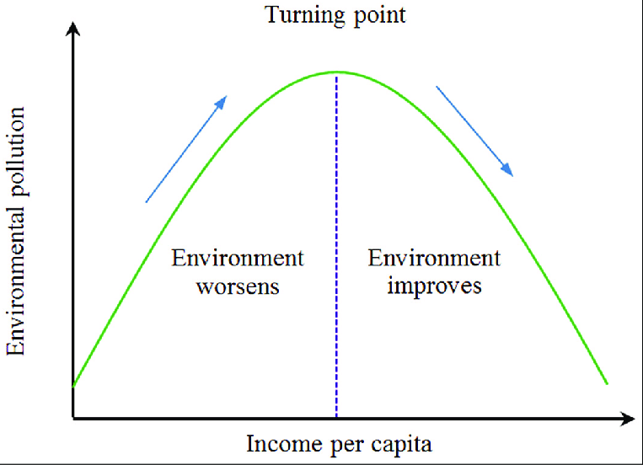

EKC is substantiated empirically and emerged after 1990s. Among all the empirical studies few of them showed the operation of the inverted U shaped EKC. Gross and kruger in 1994, Stern and common in 2001, Selden and song in 1994, Shafik and Bandyopadhyay in 1992, panayotou in 1993 showed this successfully. The commonality of these empricial analysis was that they all taken micro level data (firm level) and cross sectional and pooled data . Furthermore, taken local pollutants like SO2 or Nox.(Horvath,1997 and Holtz-Eakin and Selden, 1995).

However, most of the empirical analysis with global pollutants like Co2, energy consumption etc are opposing the EKC theory. Besides, in developing countries with co2, energy consumption as global pollutants, the EKC is monotonically rising or takes a downturn after a considerable period.

Studies related to developing economies include Focacci (2005) and Kohler’s work (2013), which found no support for the existence of the inverted U shape EKC for India, Brazil and China and south Africa, respectively. However, Ahmed and Long (2012) using data from 1971 and 2008 for Pakistan confirms the EKC hypothesis to exist.

Extensive reviews of the literature on the existence and robustness of the EKC are done by Dinda (2004) and Strern (2004).

In this paper we concentrated on the explanation that are primarily related to the ‘liberalized Growth’ oriented economy. As income rises the environment degrades initially.

Environment being the luxury good that is as income increases people attain a higher standard of living and care become more environment conscious and demand for more better environment and demand environment induces structural changes in the economy that lead to reduction of environmental degradation. Works by Pezzy (1989), Selden and song (1994), Baldwin(1995) mainly concentrate on the changes income elasticity of environmental quality demand. With growth and development an economy manages to accumulate many capital goods, wealth and technical skills. This then can we used to clean the mess of the past activities.

As the growth reaches a maximum level then people desire for better condition and standard of living also develops. World Bank and other international institutions (WTO) are using this theory to claim that the best way to deal with pollution is to get rich first and then clean up the junk. So, economic growth is a precondition for environmental improvement.

Trade liberalisation or Free trade can be good for environment (Antweiler et.al 2001). Trade raises per capita income levels in developing countries and by raising real income it will generate demands for environmental quality because higher income individuals want a cleaner environment.

Wheeler (2000) asserts that globalisation can also be seen as compatible with pollution reduction as it raises competition and with the increased investment poor economies improve their environmental quality.

Reppelin-Hill,1999, Liddle,2001 asserts that trade can create technological diffusion in developing economies which will change the “composition” of production by introducing New R&D with cleaner technologies which lead to reduction in dirty good. Though a close examination of the empirical results reveal that existence of the EKC theory is mainly confined to the developed countries.

Janicke et al,. 1997, Copeland and Taylor,1995, Cole et al.,2000 study find that the Displacement Hypothesis and pollution heaven hypothesis are giving critique that the EKC theory is applicable in the developed countries because of their shifting of dirty good manufacturing industries.

**Objective of the Study**

* To examine the effects of liberalisation, globalisation and environment in post reform India. To Test the Null Hypothesis, Ho: being that environment kuznet curve is applicable in India.
* To examine the direction and strength of causality between carbon dioxide (proxy for environmental degradation) and Gross domestic product per capita (proxy for economic growth) in both short run and long run.

DATA

The study focuses on the period from 1990 to 2021 because of data availability. The environmental quality indicators (Co2 emission per capita) are derived from **World development indicators (WDI) of the World bank** and the Gross domestic product (GDP) per capita income is derived from world bank under **PPP assumption and calculated in 2011 US$ terms**. All the series are used in their natural logarithm forms. Following table summarizes the descriptive statistics of study.

Methodology

ΔEIt=α+∑BkΔEIt−k +ΣDkΔ(GDPCt−k)²

**βo = Intercept**

**El=Environmental quality(co2 is the proxy for EL)**

**Co2= Carbon Dioxide Emission per Capita**

**GDPC = Gross Domestic Product Per capita**

where Δ denotes the first difference operator, *EI* is the environmental quality indicator chosen (in our case CO2 emissions); *GDPC* is the GDP per capita, *Bk* and *Ck,* are the coefficients of lagged *ΔGDPC,* to be estimated.

This study applies Cointegration technique approach introduced by Nobel laureates Robert Engle and Clive Granger in 1987. Cointegration is a technique to find the long run relationship between two non-stationary variable and its prerequisites is that the time series variables must be integrated of the same order.

**Rule pertaining to integrated series linear combinations**

* **xt~ I(0) => a + b xt~ I(0)**
* **xt~ I(1)=> a +b xt~ I(1)**
* **xt~ I(0) and yt~ I(0)=> a xt + b yt ~I(0)**
* **xt~I(0) and yt~I(1)=> a xt + b yt ~I(1) i.e.I(1) is a dominant property.**
* **Generally if xt~I(1) and yt~I(1) then a xt+b yt~ I(1)**

The general steps to perform cointegration test are as follows: Firstly, test the order of integration of the time series using unit root tests such as ADF or PP or KPSS test and the series should be integrated of the same order. Secondly, estimate a simple regression and obtain the residuals. Thirdly, test the stationarity of the residuals using unit root tests. Now, if the residuals are stationary, then the series are cointegrated but if the residuals are not stationary then there doesnot exists a long run relationship among the time series variables. If the variable found to be cointegrated we can find the short run dynamics of the relation using ECM. Then we move forward to test Granger Causallity using the F-test. The null is lagged value of one variable donot explain the variation in the other variable. If value in F statistic is greater than the critical value, then the null is rejected and granger causality is confirmed.

Empirical result and Discussion

Unit Root Test

Unit root test is used in this study to check whether the series are stationary or not and to see if they are stationary at the same order. In this study the variables are stationary at the first order. The presence of unit root indicates the non-stationarity of the series, while the absence of a unit root indicates a stationary series.

The values reported in the Table 2. indicates that the two variables i.e., Gross domestic product per capita and co2 emission per capita are stationary at first difference, that indicates they are integrated at order one. P value is 0.01 for GDPC at first difference. So, we reject the null hypothesis at the first difference and conclude that variable is stationary. By the same token, P value for Co2 emission is 0.01056 implies that the variable is stationary and we reject the null hypothesis at the first difference. Hence, it paves the way to use the cointegration techniques of engle granger.

Table 2. Unit root test

|  |  |  |  |  |
| --- | --- | --- | --- | --- |
| Variables | T-statistics | | Order of integration | P value |
|  | Level | 1st Difference |  |  |
| GDPC | -12.949 | -28.622 | I (1) | 0.01 |
| Co2 emission | -3.7829 | -23.038 | I (1) | 0.01056 |
|  |  |  |  |  |

Table.3 Regression Summary

|  |  |  |  |  |
| --- | --- | --- | --- | --- |
|  | Estimate | Std.error | T value | P value |
| Intercept | -6.15 | 0.17 | -35.7 | 0.00 |
| GDP capita | 0.77 | 0.02 | 36.23 | 0.00 |
| Observations: 32 | Dependent Variable: co2.ts | *Adj.R²=0.98* | F(1,30)1312.63 | *R²=0.98* |

**The model fit statistics show how well the model explains the variation in the dependent variable. The R-squared is 0.98, which means that 98% of the variation in co2.ts can be explained by gdp.ts. The F-statistic is 1312.63 which tests the overall significance of the model. The p-value is 0.00 which means that model is statistically significant at the 0.05 level**

**The intercept is -6.15 implies that when gdp capita is zero co2 is negative. The coefficient of gdpcapita is 0.77 imply the slope of the regression equation. It implies that as gdp increases by one unit carbon dioxide(co2) increases by 0.77 unit.**

Table.4 Unit Root for Residual

|  |  |  |  |  |
| --- | --- | --- | --- | --- |
| Data | T-statistic | TNP | P-value | H1 |
| Resid | -3.3912 | 2 | 0.9123 | stationary |

Here, the residual P-value is greater than 0.05 implies that the relationship is insignificant and caused do to fluctuation of sampling. So we fail to reject null hypothesis and conclude that there is no cointegration or long term relationship between Environmental quality (co2.ts) and GDP per capita in the context of developing country(India) on the basis of Environment Kuznets curve.

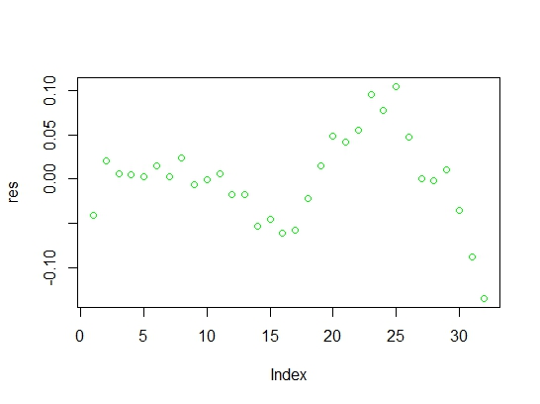

Causality Test

Table.5 implies, In case 1, Ho co2 doesnot granger cause GDP i.e., there is no cause and effect relationship between Carbon dioxide and Gross Domestic Product per capita.

Likewise, In case 2, Gross Domestic Product per capita and carbon dioxide doesnot have any cause and effect relationship. It is evident as in both case P-value is higher than 0.05.

Table.5

|  |  |  |  |
| --- | --- | --- | --- |
| Null Hypothesis | Null Hypothesis | P-value | Causal Relation |
| Case 1 | Co2 doesnot granger cause GDP | 0.754 | No relation |
| Case 2 | GDP doesnot granger cause co2 | 0.4509 | No relation |

**Conclusion**

The attempt to show the importance of the Gdp per capita of the environmental quality of a country, this works aims to examine, on the one side, the existence of an EKC type of relationship in India. If the relationship was established, then it implies that if economic development continues then after a threshold level the environmental quality improves. However, due to paucity of evidence we cannot establish long run relationship between environmental quality (co2 is the proxy for environmental quality) and GDP per capita.

To conclude, this work attempted to test the EKC hypothesis in post reform Indian context but failure of the EKC in India directed us to survey the alternative explanation of waning environmental qualities in India.

Therefore, the neo-liberal policies and trade liberalisation may have been criticized in places but the motive is to bring out the failure of valuation method of environmental goods and natural resources inside the neo-classical market territory. The Other costs of environment and ecological loss in the long run show the narrow down nature of marketbased valuation which is the core of the policies aimed towards globalizing economy.

R**eferences**

**Ahmed, K., Long. W. (2012). Environmental Kuznets curve and Pakistan: An Empirical Analysis. Procedia Economics and Finance 1: 4-13**

**Akira,H., Tetsyua,T., Shunsuke,M; “Does Trade Liberalization Reduce Pollution Emissions?”; RIETI Discussion Paper Series 08-E-013**

**Grossman, G.M., Krueger, A.B. (1991). Environmental impacts of the North American Free Trade Agreement. NBER Working paper 3914.**

**Stern. D, Common. M, Barbier.E.B; “Economic Growth and Environmental Degradation: The Environmental Kuznets Curve and Sustainable Development”; *World Development,* Vol. 24, No. 7, pp. 1151-l 160, 1996.**

**Selden, T.M. and Song, D. (1994). Environmental quality and development: Is there a Kuznets curve for air pollution?. Journal of Environmental Economics and Environmental Management 27: 147-162.**

**Kuznets, S. (1955). Economic growth and income inequality. The American Economic Review 45: 1-28.**

**Kohler, M. (2013). CO2 Emissions, Energy Consumption, Income and Foreign Trade: A South African Perspective. Economic Research Southern Africa (ERSA) working paper 356.**

**Focacci, A. (2005). Empirical analysis of the environmental and energy policies in some developing countries using widely employed macroeconomic indicators: the cases of Brazil, China and India. Energy Policy 33: 543-554**

**Antweiler, W., Copeland, B.R., Taylor, M.S., 2001. Is free trade good for the environment? American Economic Review 91 (4), 877–908.**

**Arrow, K., B. Bolin, R. Costanza, P. Dasgupta, C. Folke, C.S. Holling, B.-O.Jansson, S. Levin, K.-G.Maler, C. Perrings and D. Pimentel (1995), Economic growth, carrying capacity and the environment, Ecological Economics 15(2): 91–95.**

**Dinda,S; “Environmental Kuznets Curve Hypothesis: A Survey”; Ecological Economics 49 (2004) 431– 455.**